FIRE FIGHTING ROBOT
The design that's being presented is concentrated on a firefighting robot. Robots are able of performing tasks in a more efficient, cost effective and accurate manner than humans. Fire assumes a significant job in a mortal life still alongside that its dangerous too. A fire fighter work entails detecting and extinguishing fires. It is an amalgamation of fire detection & alarming devices working in tandem with each other with an objective to sense the initial signs of fire and warn.

Problem Statement
Fire and Gas leak incidents poses a significant threat to life and properties a certain condition poses difficult to reach by human and lack of quick reaction may causes serious damage. Therefore, fire- fighting robot are operated in places where firefighters are unfit to work. Besides that, firefighting robots can be used for guarding fire fighters from extreme peril in Petro- chemical, chemical dangerous product, toxin or explored fire accidents.

Proposed Solutions
1. Our system will detect the Fire and Gas leak in real time.
2. Alams the User and Fire station.
3. Shuts off the fire using fire extinguisher or water.
4. It acts a quick reaction which will save many lives and properties
5. It is automated system so no risking of human life.
6. It can reach to narrow spaces.
7. It has more mobility.

Target Audience
1. The primary users of this solution are homeowners and apartments who are looking for primary fire safety system
2.Military and defense
3.Small fire departments.
4.Forest Areas

Construction
To construct the firefighting robot, the required components are as follows
- Arduino Board(uno)

2.USB Cable
- GAS sensor
- Servo motor
- Flame sensor module
- L298 Motor drive module
- L293 Motor Driver Module
- Mini DC Submersible Pump
- 12V Battery
- Switch
- GSM module
- Buzzer

Connections is as follows
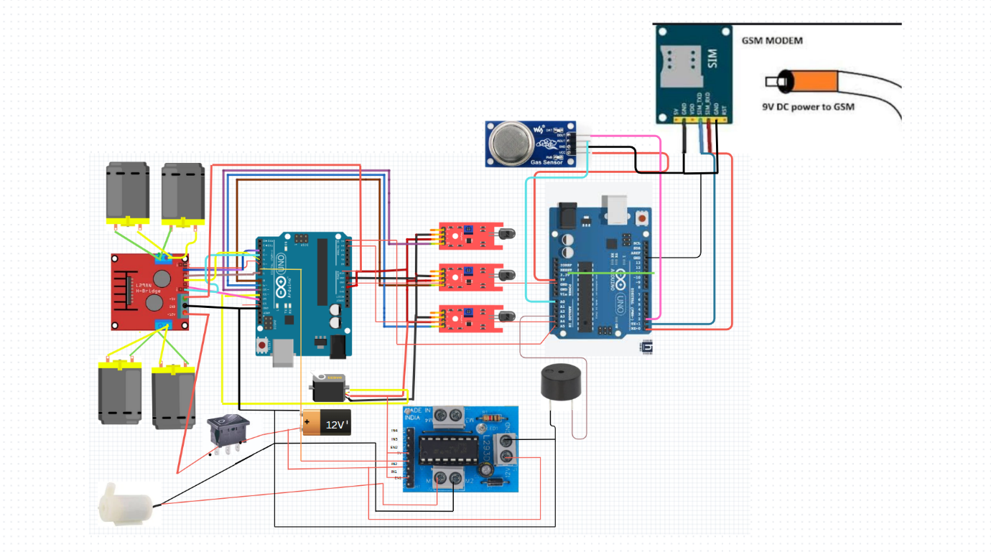

PIN Diagrams
L298N Driver pins | Arduino pins
ENA | 3
IN1 | 12
IN2 | 4
IN3 | 7
IN4 | 2
ENB | 5

L293 Module pins | Arduino pins
12V | 12V
GND | GND
5V | 5V
EN1 | 5V
IN1 | GND
IN2 | 6

Servo Pins | Arduino pins
VCC | 5V
GND | GND
SIGNAL | 11

Flame Sensor | Arduino pins
VCC | 5V
GND | GND
D0(RIGHT) | 9
D0(FORWARD) | 8
D0(LEFT) | 10

Fire Fighting Robot continuously monitors the temperature at four sensors and also detects a smoke by using Gas sensor. If fire accident is true, the robot moves to the direction to which the temperature is recorded to be the relatively maximum among the four sensors, it gives message to the Arduino. Then Arduino sends the signal to the motor driver and thus water is sprayed in the direction of the fire.

CODE

#include <Servo.h>
Servo myservo;
int pos = 0;
int motor_speed = 70;
boolean fire = false;
#define Left 9 // left sensor
#define Right 10 // right sensor
#define Forward 8 //front sensor
#define LM1 2 // left motor
#define LM2 7 // left motor
#define RM1 4 // right motor
#define RM2 12 // right motor
#define pump 6
void setup() {
pinMode(Left, INPUT);
pinMode(Right, INPUT);
pinMode(Forward, INPUT);
pinMode(LM1, OUTPUT);
pinMode(LM2, OUTPUT);
pinMode(RM1, OUTPUT);
pinMode(RM2, OUTPUT);
pinMode(pump, OUTPUT);
analogWrite(3, motor_speed);
analogWrite(5, motor_speed);
myservo.attach(11);
myservo.write(90);
}
void put_off_fire() {
delay (500);
digitalWrite(LM1, HIGH);
digitalWrite(LM2, HIGH);
digitalWrite(RM1, HIGH);
digitalWrite(RM2, HIGH);
digitalWrite(pump, HIGH);
delay(500);
for (pos = 50; pos <= 130; pos += 1) {
myservo.write(pos);
delay(10);
}
for (pos = 130; pos >= 50; pos -= 1) {
myservo.write(pos);
delay(10);
}
digitalWrite(pump,LOW);
myservo.write(90);
fire=false;
}
void loop() {
myservo.write(90); //Sweep_Servo();
if (digitalRead(Left) ==1 && digitalRead(Right)==1 && digitalRead(Forward) ==1) {
digitalWrite(LM1, HIGH);
digitalWrite(LM2, HIGH);
digitalWrite(RM1, HIGH);
digitalWrite(RM2, HIGH);
}
else if (digitalRead(Forward) ==0) {
digitalWrite(LM1, HIGH);
digitalWrite(LM2, LOW);
digitalWrite(RM1, HIGH);
digitalWrite(RM2, LOW);
fire = true;
}
else if (digitalRead(Left) ==0) {
digitalWrite(LM1, HIGH);
digitalWrite(LM2, LOW);
digitalWrite(RM1, HIGH);
digitalWrite(RM2, HIGH);
}
else if (digitalRead(Right) ==0) {
digitalWrite(LM1, HIGH);
digitalWrite(LM2, HIGH);
digitalWrite(RM1, HIGH);
digitalWrite(RM2, LOW);
}
delay(300);
while (fire == true) {
put_off_fire();
} }

